Diagnostic Study on
Leather Goods, Sialkot
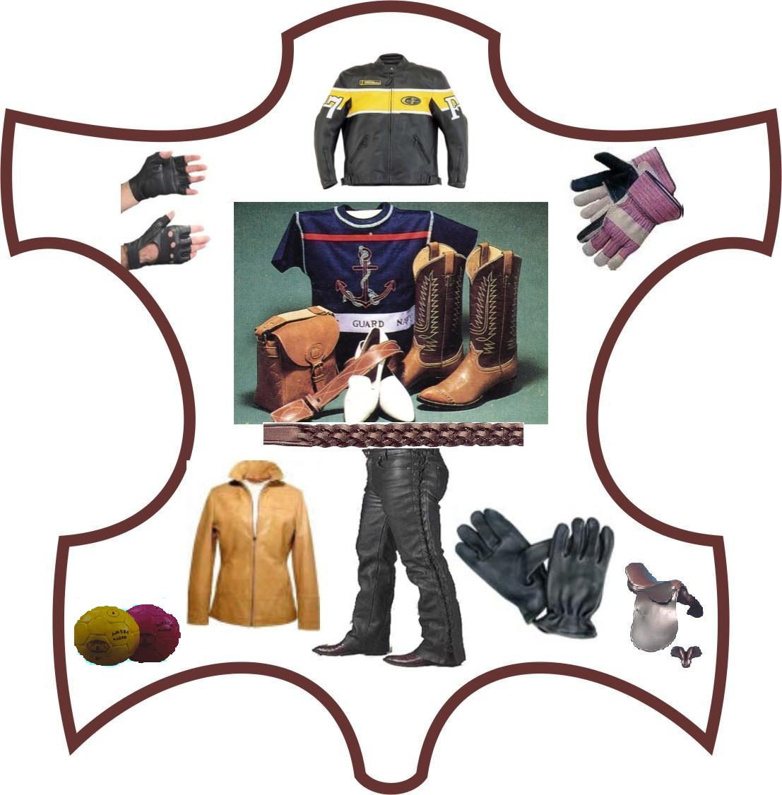

By: S. M. ATHER RAZA ZAIDI/TAHIR HAFEEZ
Cluster Development Agents
April-2006
Punjab Small Industries Carporation
Cluster Development Programme for SMEs in Punjab
Joint Project of PSIC, SMEDA & UNIDO

Small Industries Estate, U.K Road, Sialkot
Phone: 052-3255475 & 3251296 Fax 052-3250786 E mail: atherzaidi7@yahoo.com

Table of Contents
Objective of Study__________________________________________ _____________4
1. Description of Cluster 6
1.1.1 Definition of Product 6
1.1.2 Geographical Location 6
1.1.3 Cluster History 6
1.1.4 Analysis of business operations of Principle firms 7
1.1.4.1 Preparation of Raw Material __________________________________________ 7 1.1.4.2 Production Operations 7
1.1.4.3 Quality Assurance 9
1.1.4.4 Sales/Marketing 9
1.1.5 Leather Goods Industry Overview _______________________________ ______10
1.1.5.1International ___________________________________________________________10
1.1.5.2.National ______________________________________________________________ 11
1.1.5.3.Sialkot Leather Industry __________________________________________________12
1.2. Core Cluster Actors. _____________________________________________________ 14
1.2.1.Manufactures ____________________________________________________________14
1.2.2 Makers _________________________________________________________________14
1.3. Other Cluster Actors.______________________________________________________ 14
1.3.1.Raw material Suppliers ____________________________________________________14
1.3.2.Machinery Suppliers ______________________________________________________14
1.3.3.Freight Service Providers __________________________________________________14
1.3.4 Vendors/Suppliers of Raw Material __________________________________________14
1.3.5.Private BDS Providers ____________________________________________________14
1.3.6. Financing ______________________________________________________________ 15
1.3.7. Human Resources 15
1.4. Associations _____________________________________________________________15
1.4.1.Pakistan Leather Garments Manufactures & Exporters Association__________________15
1.4.2.Pakistan Gloves Manufactures & Exporters Association __________________________15
1.4.3.Sialkot Chamber of Commerce and Industry __________________________________16
1.5. Current Institutional Linkage ________________________________________________16
1.5.1.1.Punjab Small Industries Corporation _______________________________________ 16
1.5.1.2. Small and Medium Enterprises Development Authority. _______________________ 17
1.5.1.3.Export Promotion Bureau ________________________________________________ 13
1.5.1.4.Leather Products Development Institute. Sialkot. _____________________________ 18
1.5.1.5.Government Apprentices Training Centre (ATC) 18
1.5.1.6.Vocational Training Institute(TEVTA) 18
1.5.1.7 Banks 19
1.5.2 Transaction cost Analysis Matrix. ___________________________________________19
2. Cluster Map (Current) 20 3. Value Chain 21
4. SWOT Analysis of Cluster __________________________________________________23
4.1 Strengths 23
4.2 Weaknesses 23
4.3 Opportunities 24
4.4 Threats 24
5. Major Problems & issues of the cluster 25
5.1. Technology Constraint. 25
5.2 Marketing constraint 25
5.3 Human Resources constraint 25
5.4 Regulatory constraint ____________________________________________________25
5.5. Financial constraint _______________________________________________________20
6. Porter Framework (Leather Goods Cluster Sialkot 26
7. Cluster Vision, Targets & Activities 28
8. Strategy 29
9. Cluster Map( Future) 31
10. Tentative Action Plans/ Implementation 32
ANNEXURES:
Annex A Stake Holders of Leather Goods Cluster, Sialkot 33
Annex B Questionnaire To Evaluate Current Situation Of Industry 34
Annex C List Of Training Institutes, Trade Bodies And Other Organizations 37
Annex D Main Category Of Leather & Its Products 39
Annex E Graphs Of Export Of Sialkot 1999-2004 40
Annex F Official Methods Of Analysis Of Leather And Its Products 41
Annex G List of Secondary Data/directories 44
Annex H List of Firms who filled questionnaire 45
Annex I Abbreviations 46

Objectives of the Study:

The world has become a global village and after the Second World War the Industrialization has become the order of the day. Over the last decade, awareness about the importance of industrial Cluster and its role in promotion of economic growth has been well recognized. As a result, emphasis on Cluster and net work development has increased both in developed and developing countries. A Cluster is defined as: the Group of Industries which are producing similar items and facing common opportunities and problems situated in same area along with other stakeholders like: sellers, buyers, manufacturers, repairers, bankers, logistics, labor, institutes etc.

Cluster Development Programmes provide business in a selected Cluster with a cost of support services to facilitate their growth and development, enhancing their capacity to compete in the fiercely competitive environment.

Keeping in view the importance of Cluster Development, United Nations Development Organization (UNIDO) initiated Cluster Development Project in Pakistan in July 2001 and initially five Clusters were identified in all over the Pakistan. These Clusters were Fan (Gujrat) Cutlery (Wazirabad), Garments (Lahore), Gems & Jewelry (Karachi) and Leather (Karachi). The major activities of all Clusters were different. In this Project Experts and Partners agencies were:

- Ministry of Industries and Production. (MOIP)
- Ministry of Science and Technology (MOST)
- National Productivity Organization (NPO)
- Ministry of Commerce (MOC)
- Export Promotion Bureau (EPB)
- SME Bank
- Small & Medium Enterprises Development Authority (SMEDA)

In 2004, Punjab Small Industries Corporation, PSIC (Govt. of the Punjab) along with, SMEDA (Govt. of Pakistan) and UNIDO, also initiated a Programme titled “Cluster Development Programme for SMEs in Punjab”. Under this Programme seven industrial Clusters were identified in Punjab:

S.# | Cluster | City
03 | Leather Goods | Sialkot
02 | Domestic Electrical Appliances | Gujranwala / Gujrat
01 | Ceramic Pottery | Gujrat
04 | Wood Working | Chiniot
05 | Ginning | Rahim Yar Khan
06 | Handloom | Multan
07 | Textile Spare Parts | Faisalabad

The basic aim of the subjected Programme was the development of the Industry. Main components of the first phase of the Programme were: understanding the Cluster, there contribution, strengths, weaknesses, core competence and major issues.

After the selection of Cluster Development Agents in December 2004, the work started and after initial training at NIPA Lahore the agents were sent to their relevant Clusters. Diagnostic Study is important part of the Cluster development Programme, this study will not only reflect the current status of the cluster but also provide future plans for the development of the cluster.

1 DESCRIPTION OF THE CLUSTER

1.1. Defining the Product
The Leather Goods include the different types of the Leather manufacture items such as

1- Garments (Motor Bike, Fashion, and Protective)
2- Gloves (Working, Fashion, Military and Sports)
3- Shoes (Fashion, Sports, Military)
4- Goods (Sadlery, Bags, Belts, Straps, Decoration Pcs, Cases, Wallets, Jewellery and
Musical instruments)
5- Sports Goods (Cricket Balls, Hand Balls, Foot Balls, exercise equipments)

These Products are made up of leather which collects from some cities like Karachi, Kasur, Lahore, Multan, Shekhopura, etc. manufactured and (mostly) sold in the international market. These products have a growing demand in the world as well as nation (Local) market.

1.1.2 Geographical Location
Sialkot district is situated between Gujarat, Gujranwala, Narowal and Indian Occupied Jammu & Kashmir. It is 829 feet above sea level. The city of Sialkot having 3,016 Sq Km area with a Population 2,723,000 has a density of 903 person/Sq Km. It has four Tehsials (Sialkot, Daska, Pasroor and Sambrial). The per Capita income of US $ 1,000 of Sialkot is the highest in Pakistan, as compared to US$ 450 in other part of Pakistan.

In Sialkot there are around 7,000 Industrial Units registered with Chamber of Commerce & Industry having a work force of about 105,00 employees. The major areas where Leather Cluster exists are Defence Road, Daska Road, Sadpur Road, Pasroor Road, Marala Road, Chiti Shekihan, Zafarwal Road, Wazairabad Road, Kashmir Road etc

1.1.3 Cluster History
Sialkot is known world over for its expertise in manufacturing and export of sports goods and accessories for the past 100 years or so. The city was a hub of sports goods manufacturing even before the independence. It bravely passed through the turmoil created by fleecing capitalists and investors and proved to the world that the skilled hands can establish and run any business rather than mere power of capital. The products are mostly made for international market and have received worldwide recognition merely because of the care that goes into selection of raw material, designing and manufacturing. International linkages of cluster were developed mostly in the British colonies. Product range being manufactured includes, soccer balls, volley balls, rugby balls, beach balls, exercise balls, cricket balls, hockey balls, baseball balls, tennis balls, shuttle cocks, nets, gloves, hockeys, cricket bats, baseball bats, protective guards, pads,etc.

Ever since the sports goods cluster entered the international markets, the local entrepreneurs put in a lot of emphasis on building strong linkages with buyers. After linkages, second important aspect is the skilled workforce; there was a “Uniform Factory” which was established by the British government during 1930s to supply uniforms kits and accessories to British army stationed in sub continent. During its peak period it had 3000+ work force including stitchers, cutters, press men, packers, accountants, administrators, etc. After the partition the factory was closed and the machinery was sifted to a small town in north of Islamabad. Some of the workforce moved along the factory while the majority decided to stay back. Some of these workers went to UK, Middle East, Lahore, Karachi etc, while the ones left back were hired by the sports goods manufacturers to make low end sports wear for local market. As the sales in local markets at that time (and still today) were very low, and export had not started yet, these skilled workers diversified their skills towards leather gloves manufacturing which was a growing business. Lately with the introduction of leather garments sector, many of these ended up in stitching leather garments. By the time Leather Goods exports were beginning to register a noticeable figure, during early 1980s, the city had an abundant supply of skilled work force capable of making any Leather garment the customer wanted. The major type of industrial units in Sialkot are Leather Garments, Leather Gloves, Tanneries, Sports Goods, Surgical, Textile Garments, Musical Instruments, Cutlery and other agricultural related industries. Sialkot was selected to supply footballs in 1998 World Cup. Sialkot Cluster holds many lessons for the rest of Pakistan’s economy. As regard Leather Sector there are about 1,600 units registered with Chamber of Commerce & Industry and in year 2003-2004 the Export of Sialkot was US $ 660 Million, in which the Leather related Export was US $ 217 Million. The number of individuals involved in manufacturing (proportionate to population size) is over four times higher, the number of manufacturing establishments is six times higher, and the Exports are eighteen times higher compared to the rest of the country.

1.1.4 Analysis of Business Operations of Principle Firms

1.1.4.1 Preparation of the Raw Materials
Following are the main raw materials or inputs which used in the production of Leather Goods.
Raw Leather (Tannery):
Raw to Wet Blue, Wet Blue to Finish, Raw to Finish. Apart from this raw leather of some proprietary are also supplied directly by the buyers and/or imported. Local Raw Leather are mostly purchased from Tanneries of Sialkot (about 250 tanneries), Lahore/Shekhupora (about 50 tanneries), Kasur (about 237 tanneries),Karachi (about 190 tanneries) and Gujranwala (about 50 tanneries). Large , Medium and small firms buy directly from manufacturers and local dealers and stockiest. Some exports have their own tanneries and they buy raw material as their requirements.
Accessories.
Zippers, buttons, fusing, eyelets, snaps, etc. Mostly these are of foreign origin.
Sundries:
Labels, hang tags, poly bags, marking taps, embroidery patches, thread, etc.

1.1.4.2 Production Operations

Pattern Making

Production operations start from pattern making of the leather garment/Gloves. Pattern making is usually done manually as expert pattern makers are available easily, however some large firms have installed their own CAD based pattern making machines. Pattern made on CAD is of superior quality. Small exporters usually prefer manually made patterns due to its cheaper costs. Now some CAD based pattern making facility is also available in some training institutes like LPDI & VTI

Cutting
There are two cutting techniques are in practice, direct cutting with knife and cutting with scissor after tracing part of the pattern on the Leather. Cuttings are bound in bundles and stored accordingly.

Stitching
Some Medium and large firms follow “chain” system of stitching. In this system one garment is made on a number (4—6) machines; each worker is stitching only some portions of garment. In this method the average productivity of worker is around 5—6 times more than traditional style. It also results in job specialization and reduces the quality problems.

Small and cottage size units still follow the traditional one machine one garment approach. This puts an additional burden on the costs of production in the form of lower worker productivity, longer lead time, higher rate of rejections, worker fatigue, etc.

Checking/Trimming
Extra threads, oil stains, loose fabric portions, etc are removed. This is a labour intensive job and is mostly carried out by low/semi skilled workers with in the exporting unit.

Pressing/ Ironing
It’s an important part of the finishing process. Good factories use steam irons but small/cottage use traditional irons. Steam iron press setup has higher capital as well as operating costs, but the quality of press is far better.

Packing
It’s carried out according to customer requirements.

The Production Flow Chart

Leather Product (Gloves/Garments) from Leather is as under

Purchase of Skin/Hides
Selection
(1-day)
Wet-Blue Process in Tannery (7-10 days)
Sale out to other Tannery
Selection
(1-day)
Process of Dying in Tannery (2-3 days)
Process of Finishing in Tannery
Sale out
Process of Finishing in Tannery (3-5 days)

Issuance of Leather/ Purchase of Leather
Selection
Cutting
(1-day)
Fusing/Embossing
(If Required)
Stitching
(1-2 days)
Buttoning or Lacing (If Required)
Checking
(1-day)
Repairing/Re works
(If required) (1-day)
Checking
(1-day)
Pressing/Ironing

Packing
(1-day)

Note: The involvements of labour of every process are different and it varies according to production volume, (e.g Selection 1-3 persons, Wet Blue Process 6-10 person, Dying & Finishing Process 4-15 person, Cutting, Stitching, Pressing packing 5-15 persons) so it is difficult to write in the flow chart.

1.1.4.3. Quality Assurance
Quality holds an important place in the entrepreneurial culture of Sialkot. Ever since the city entered international markets, this value is being strengthened day by day. Fifty percent of units manufacturing & exporting Leather Goods are ISO 9000:2000, CE registered. Apart from QMS requirements, every effort is made to produce goods on time and free of defects. During the production operations, quality checks are maintained at cutting, stitching and finishing stages.

1.1.4.4. Sales/Marketing setups
Most of the companies have there separate sales departments to look after international sales. These departments also carry out functions of merchandising. Usually SMEs owners marketing and attend the fairs themselves. Meetings with buyers and potential customers are also held during and after the trade fairs. Due to high costs of attending these fairs and problems in getting visas, small and cottage level units owners seldom participate in international fairs; their emphasis to contact potential customer through email or fax.

1.1.5. Leather Goods Industry Overview.

      - International

Leather is a by product of Animal and it is world largest industry based on by product. Leather has many uses in the world and it is one of the valuable & important international trading commodities. The international export of leather & its goods in 2003 was 72.45 US $ Billion. There are lot of items of Leather Goods in which some important are given below.

Belts, Gloves, Garments, Footwear, Sadlery ,Straps, Bags, Ladies Bags, wallets, Briefcases, Watch stripes, Key chains, Tea mats, Pen holders, Musical instruments, Sports Goods, Jewellery etc.

The use of Leather Goods is going to upwards. The countries like China where production cost is very low are capturing the international markets and having about 27% share While the industry of other countries like Italy, France, Germany are going up due to availability of latest machinery and technology.
 | 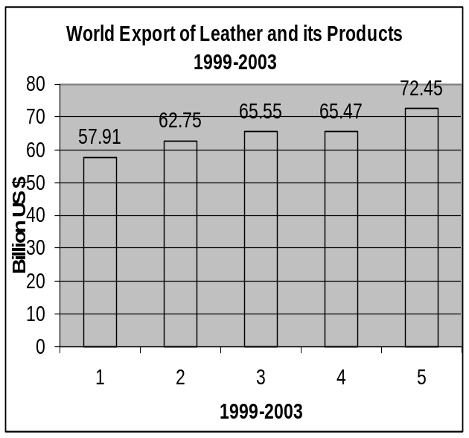
  International Export Figure of Leather and its Products in 2003
  Rank | Country | Value ,000 US $ | Word  % share
  1 | CHINA | 19,240,562 | 26.6
  2 | ITALY | 13,985,295 | 19.3
  3 | FRANCE | 3,347,780 | 4.6
  4 | GERMANY | 3,216,009 | 4.5
  5 | SPAIN | 2,998,678 | 4.1
  6 | BRAZIL | 2,778,627 | 3.8
  7 | INDIA | 2,204,709 | 3.0
  8 | BELGIUM | 1,899,640 | 2.6
  9 | KOREA REP. | 1,627,955 | 2.3
  10 | USA,PR,USVI | 1,593,948 | 2.2
  18 | PAKISTAN | 818,122 | 1.1
   | Others | 18,742,754 | 25.9
   | TOTAL Export | 72,454,079
  Source www.Leatherindia.org/Exportingcountries.asp

1.1.5.2. National
Pakistan is an established name in the world of Leather Products. According to a Survey conducted by Leather Industry Development Organization in 1997 which was the last survey of its kind on Leather Industry by any organization, the details of Leather Industry of Pakistan are as under:

S.# | Type of Industry | Total unit  In Pakistan
01 | Tanneries | 784
02 | Leather Garments | 355
03 | Leather Footwear | 523
04 | Leather Goods | 134
05 | Leather Gloves | 347
 | Total | 2,143
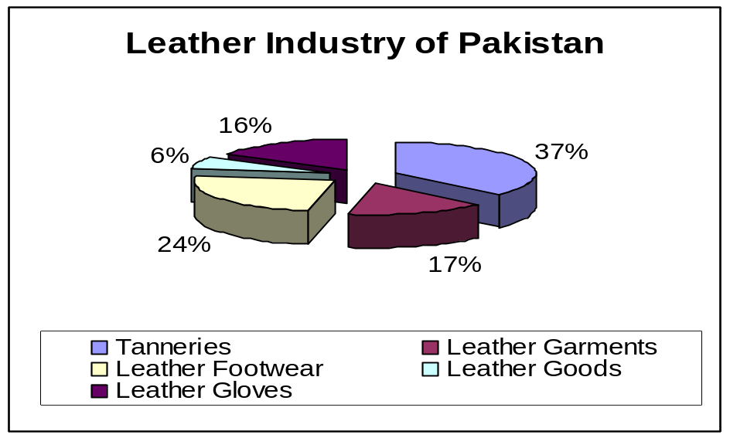

As far as Pakistan Leather Cluster is concerned, it is the need of the hour to start such projects through which the cost of Leather could be minimized. There is a need of proper marketing plan for the Leather Cluster; individual marketing efforts are not providing satisfactory results, Instead of collective and combined marketing achievements by a group of people in a network which is now rapidly adopting in developed as well as developing countries because of its good results.

Exports of Pakistan(Leather & its Products):
The statistics of Leather Export from Pakistan indicates that Exports related to Leather are going up, but still there is need to do a lot of work for development especially in the areas of Leather Goods, Gloves and Footwear.

Export of Leather and Leather Products from Pakistan during 1999-2005
Article | 1999-2000 |  | 2000-2001 |  | 2001-2002 |  | 2002-2003 |  | 2003-2004 |  | 2004-2005
Article | Value,  ,000 $ | %  share | Value | % share | Value | %  share | Value | %  share | Value | % share | Value | % share
Article | Value,  ,000 $ | %  share | ,000 $ | % share | , 000 $ | %  share | ,000 $ | %  share | ,000 $ | % share | ,000 $
Leather | 175,163 | 32..33 | 232,921 | 33.6 | 239,934 | 35.71 | 234,774 | 33.79 | 251,693 | 33.83 | 303,606 | 32.35
Gloves | 29,839 | 5..51 | 37,332 | 5.39 | 51,324 | 7.64 | 56,969 | 8.2 | 70,722 | 9.5 | 164,333 | 17.51
Garments | 300,143 | 55..39 | 375,597 | 54.18 | 321,341 | 47.84 | 232,316 | 33.44 | 323,656 | 43.5 | 329,272 | 35.09
Goods | 8,680 | 1.6 | 12,587 | 1.82 | 10,530 | 1.57 | 97,262 | 14 | 19,965 | 2.68 | 33,169 | 3.53
Foot Ware | 28,044 | 5.17 | 34,755 | 5.01 | 48,613 | 7.24 | 73,397 | 10.57 | 78,045 | 10.49 | 108,093 | 11.52
Total | 541,869 |  | 693,192 |  | 671,742 |  | 694,718 |  | 744,081 |  | 938,473
Source: Export Promotion Bureau (Key Indicators)

Export of Leather and its Products from Pakistan During 1999 to 2005
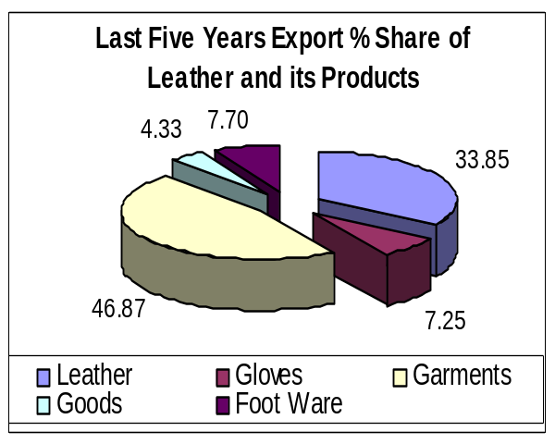 | 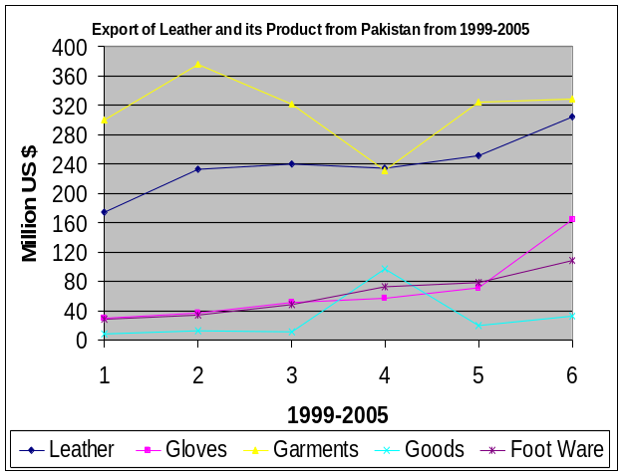

Source: Export Promotion Bureau (Key Indicators)

1.1.5.3. Sialkot Leather Cluster:
Sialkot Leather Cluster is one of the largest industries of Pakistan. In Sialkot the Leather Cluster is scattered over the whole city. Daska Road, Defence Road, Marala Road, S.I.E, Uggoki Road, Kashmir Road, Saidpur Road, Pasroor Road, Waziarabad Road, Zafarwal, Road and some other areas are the Clusters of different type of Leather products units.

According to survey conducted by Leather Industry Development Organization in 1997 the total number of units related to Leather were 768 in which 250 units in SMEs. Unfortunately that was last survey which was conducted for Leather sector in Pakistan. While according to Sialkot Chamber of Commerce there are 1,600 registered firms related to Leather and its Products

Pakistan & Sialkot Leather Industry in 1997
Type of Industry | Total unit in  Pakistan | Units in  Sialkot | % share | 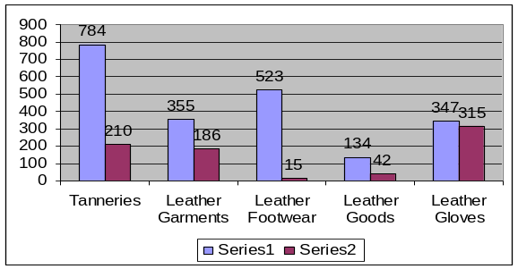
Tanneries | 784 | 210 | 26.79
Leather Garments | 355 | 186 | 52.39
Leather Footwear | 523 | 15 | 2.87
Leather Goods | 134 | 42 | 31.34
Leather Gloves | 347 | 315 | 90.78
Total | 2143 | 768 | 35.84

Export from Sialkot Dry Port during 1999 -2005
(Value in Million Rs)
Commodity | 99-00 | 00-01 | 01-02 | 02-03 | 03-04 | 04-05
Leather Goods/ Garments Etc | 6,135 | 8,339 | 9,679 | 11,196 | 11,145 | 7,002
Leather Gloves | 3,658 | 4,014 | 3,441 | 2,331 | 1,869 | 4,333
Total of Leather Product Exports | 9,793 | 12,353 | 13,120 | 13,527 | 13,014 | 11,335
Total Export of Sialkot | 28,577 | 33,149 | 38,376 | 39,784 | 39,600 | 38,831
% age of Sialkot Export | 34.27% | 37.26% | 34.19% | 34.00% | 32.87% | 29.19%
Source: Sialkot Dry Port

In 2003-2004 Sialkot Leather Cluster earned 217 Million US $ US, which is 29.17% of Pakistan Leather and its Product Export. According to data, received from Sialkot Dry Port Trust the Export share of Sialkot of Leather and its Products are going down, especially Leather Gloves which has been reduced by 51% from last five years. (Graf is attached on Annexure J) As the WTO has been implemented, there is need to boost up Cluster on immediate basis.

Infrastructure Facilities Available in Sialkot
- Sialkot Junction Railway Station & Carpeted Roads
- Sialkot Dry Port & Strong Cargo/Freight forwarding system
- FM Radio Station
- Strong Banking network, 23 Different National and International Banking Networks
- Digital Telephone exchanges & Internet provider companies
- Electricity Supply & Natural Gas
- International Air Port (under construction)
- Leather Physical Testing Lab (some physical tests of Leather)
- Technical Training Institutes
- Trade Bodies
- Small Industrial Estates

1.2. Core Cluster Actors
The Core Cluster actors can be divided into two broad categories:

1.2.1 Manufacturers
In Sialkot Leather cluster, there are 558 manufacturing units of Leather Goods in which 186 units are Leather Garments, 315 units are Gloves, 15 units are Foot wear and 42 units are different leather Goods.

1.2.2 Makers
There are more than 60 small units of makers who only involve manufacturing activities of Cutting & Stitching of Leather Garments and Gloves. These maker works for the Exporters who have Export Orders of Leather Goods. Exporters also provide financial support and raw material to the makers.

1.3 Other Cluster Actors
There are a number of other persons who contribute to the activities of the cluster and thus play an important role. They can be classified as follows:

1.3.1 Raw Material Suppliers
Most of the raw material suppliers (Tanneries) are present in the Sialkot city, where their number is estimated to be more than 250. Local Raw Leather is also purchased from Tanneries of Lahore, Kasur, Karachi and Gujranwala. Medium and large firms buy directly from manufacturers for large orders, where as small and cottage firms buy from local dealers and stockiest which estimated is 50. Large and medium firms also buy from local dealers for small orders. Dealers also keep stock of raw leather (tannery) and accessories. Some manufacturers also have their own tanneries.

1.3.2 Machinery Suppliers
The number of Stitching machinery Supplier present in the cluster is estimated to be more than 10. The machine manufacturers also provide the other services like technical consultancy and machine repairing etc.

1.3.3 Freight Services Providers
The freight services providers are responsible for shifting the products, within and outside the cluster. In Cluster Sialkot, there are nearly 40 freight forwarding agencies providing countrywide services.

1.3.4 Vendors /Suppliers of Indirect Material
There are above 100 venders/ suppliers of indirect materials such as threads, chemicals, Accessories Zippers, buttons, fusing, eyelets, snaps Labels, hang tags, poly bags, marking taps, embroidery patches etc.

1.3.5 Private BDS providers
Cluster is unfortunate in this respect. Quality and availability of private BDS has been very poor. Majority of consultancy firms provide services in ISO 9000: 2004, ISO 13485, EN 46000, CE, GMP, SA8000, etc certifications. Around 10 firms provide accountancy and taxation services out of which only 1 is a CA firm. There is an absence of BDS in productivity management, marketing and sales, HR development, software, etc.

1.3.6. Financing
Financing from banks is easily available at very competitive rates. Firms usually go for ERF based loans which are provided by State bank of Pakistan through commercial banks at very nominal rates. At the moment mark-up rate for ERF loan is 9.00% pa. This loan is available for a period of 6 months, on order to order basis.

Apart from this leasing facilities are also being offered by banks and leasing companies for purchase of machinery and equipment. Almost all banks are providing finance to the Exporters.

1.3.7. Human Resource
Shop floor level HR is easily available in the cluster, although average wage level has been increasing every year. Lower and middle management staff is also easily available but unfortunately the turnover rate especially in middle management is very high. Upper management tasks are performed by the owners, who in most of the cases are not appropriately educated and trained. They learn from interaction with foreign buyers, middle management and shop floor workers.

1.4. Associations

1.4.1 Pakistan Leather Garments Manufactures & Exporters Association (PLGMEA) Northern zone
Pakistan Leather Garments Manufacturers and Exporters Association is one of the main Associations of Leather and its Goods which was established in 2001. The main purpose of the Association is to safeguard the interest of the leather garments manufactures and exporters. Association has two zones Southern & Northern. Sialkot Leather Cluster is under Northern Zone. The member of PLGMEA (Northern Zone) is 116, which are increasing year by year. The Membership Fee is Rs 15,000 + 5,500 Annual Renewal for Ordinary Class and Rs 7,500 + 3,300 Annual Renewal Fee for Associate Class. This Association provides services to its members like Dissemination of information about international trade fairs, Organizing/Participation in International Trade fairs along with EPB, issuance of visa recommendation letters, processing of R&D and Freight Subsidy refund claims. PLGMEA is also looking after common facility centre for Leather Garments industry which is established with the Funds of EPB and 20-25 entrepreneurs are availing services of that Centre.

1.4.2 Pakistan Gloves Manufactures & Exporters Association (PGMEA)
Pakistan Glove Manufactures and Exporters Association (PGMEA) is an Association of Gloves Manufacturing and Exporting unit of Pakistan. The annual membership fee of the Association is Rs 1,000 for Associate Class and Rs 600 for Ordinary Class members. Association has more than 300 members and has been providing the relative information to their members for establishing contacts to export their products, while organizing their group team to participate in Trade Fair and Exhibitions abroad for display their products. Pakistan Glove Manufactures and Exporters Association (PGMEA) is also looking after two projects, Leather Products Development Institute (CPC) and Cleaning Production Centre (CPC).

1.4.3 Sialkot Chamber of Commerce and Industries (SCCI)
Sialkot Chamber of Commerce & Industry is the largest Association of exporters of all sectors in the city. SCCI has more than 7,000 members and have a very good reputation of carrying out several projects for the development of people and city. The thrust of these initiatives has been on social development, education, civic infrastructure development, etc. Following are the projects which SCCI has initiated and implemented successfully along with support from government and international donors.
- Elimination of Child Labour from soccer ball industry.
- Establishment of Sialkot Dry Port.
- Universal primary education program.
- Sialkot Public school.
- SOS Village
- Sialkot Medical Complex.
- Sialkot International Airport (under construction)
- The Light (school for mentally handicapped children).
- Social welfare services complex.
- Tannery zone.
- Sialkot city development package: Building and renovation of city roads. Exporters contribute 0.25% of FOB value of their shipments towards this fund.

There are two classes of members, Associate Class which membership fee is Rs 850 annually and other Chamber Class which membership fee is Rs 1,300 per year.

1.5 Current Institutional Linkage

1.5.1. Institutes Linked With Cluster

1.5.1.1. Punjab Small Industries Corporation (PSIC)
Punjab Small Industries Corporation is a provincial department which supports the establishment of small and cottage industries in the province of Punjab. It has a District Development office in Sialkot. PSIC offers help in following areas

- Offering credit facilities to small and cottage industries (new and existing businesses). During last three years about 52 loan cases under Credit Scheme for Small Industries (CSSI-2002) was applied in which 44 loan cases were sanctioned. As concerned Leather Cluster 12 entrepreneurs has availed the facility of loan
- Establishing industrial areas for small industries.

PSIC Sialkot has established an Export processing zone (EPZ) at Sambrial, Sialkot with the coordination of SCCI in Sialkot.

1.5.1.2. SMEDA
Small and medium enterprise development authority was formed in October 1998 with a sole purpose of developing SMEs in the country. It has a Regional business centre (RBCs) in Sialkot. SMEDA provides following services to SMEs

- Short training programs for lower and middle management.
- Marketing advice.
- Technical advice.
- Facilitation in arranging finance from banks.
- Legal Services
- Business plan development.
- Common facilities Centres.

1.5.1.3. Export Promotion Burro (EPB)
Export promotion bureau has a mandate to promote local products in international markets. It has reserved a special quota for SMEs (20%) in all the international trade exhibitions, trade delegations, trade conferences which it arranges. It has a regional office in Sialkot.

Functions of EPB
a) Marketing
- Market Research
- Fairs and Exhibitions - local and international
- Trade Delegations
- Overseas and local publicity
- Participation in Trade Related Events
- Expo Centre - Holding of exhibitions
- Facilitation through trade officers abroad
- Seminars/Conferences/Workshops
b) Communication
- Publication of Trade inquiries/opportunities
- Library
- Export Intelligence Bulletin
- Counselling
- Year Book - Statistics
c) Human Resource Development
- Training Institutes
- Seminars on ISO 9000 and 14000
- TQM
- Social Sector Concerns
- Environmental Concerns
d) Service to exporters
- Export Facilitation committee
- Resolving problems in exports
- Simplification of procedures
- Export procedures handbook
- Establishing buyer-seller contacts
- Fax on demand and the Web site
- Interface with chambers/trade associations
- Settlements of trade disputes
e) Regulatory
- Formulation of proposals for the Trade Policy
- Implementation of Trade Policy
- Textile Quota Management
- Registration of Importers/Exporters
- Registration of Export Contracts
- Determination of Minimum Export Prices
- Issuance of GSP Certificates

1.5.1.4 Leather Product Development Institute (LPDI)

Leather Products Development Institute is established in Sialkot in 2001, to provide technical training in Leather Glove Manufacturing and Leather Garments Manufacturing Technology. This Institute is funded by Export Promotion Bureau (EPB) through Export Development Fund and Pakistan Gloves Manufactures & Exporters Association is responsible for the management. Annually 100-130 male/female students are getting training in three batches in flowing curses
- Leather Garments Manufactures Technology Course
- Leather Garments pattern making Course (manual)
- Leather Garments pattern making Course (computerized)
- Leather Gloves manufacturers Technology Course
- Leather Gloves Pattern making course
- Basic Computer operator course.

About 100 SMEs are availing facility of Pattern making, Stitching, Embroidery and consultancy from LPDI. The major issue of the Institute is the lack of modern machines and equipments for fashion designing and Leather Goods manufacturing. LPDI to work for the promotion and development of Leather & Leather Product industry while VTI is providing trainings in many fields, like Electrical, Electronic, Civil, Leather, textile and others.

      - Government Apprentices Training Centre (ATC)

This Centre is running under Technical Education and Vocational Training Authority (TEVTA) along with other technical course, Two Leather related courses are also in the list of ATC. Leather Works Sports Goods which was started in 1988 and other Leather Garments Stitching which was started in 1998. Annually two batches containing 40-45 students got trained here. The all students came from Industry vide Apprentices ordinance, thus they don’t have any problem of Job.

The skilled work force is mainly filling the need of Leather garments and Football Industry. However the Leather Products (Small Goods) training is essentially required.

1.5.1.6. Vocational Training Institute
Vocational Training institute is running under Punjab Vocational Training Council, provides training to shop floor level workers in stitching and pattern making. It is specifically meant for poor people who cannot afford the fee of such training. SMEDA has installed latest CAD for garments pattern making at this institute. Students are also trained on this CAD and then they find good employment in big units having the said facility. Around 80 students in two batches in a year have completed training. SMEs are also getting facility of pattern making and consultancy about production. This centre is facing problem of lack of stitching machines for garments stitching training.

      - Banks
Al most all the registered commercial and industrial development banks of Pakistan have their branches in the cluster Sialkot.

1.5.2. TRANSACTION COST ANALYSIS MATRIX

Agency | Training | Technology (R&D, Testing, etc.) | Design & Product Development | Market Facilitation | Credit Facilitation
PSIC | Medium | - | - | - | Medium
SMEDA | Medium | Medium | - | High | -
EPB | - | - | - | High | -
VTI(PVTC) | High | Low | - | - | -
ATC (TEVTA) | Medium | - | - | Medium | -
LPDI | - | Medium | Low | - | -
Banks | - | - | - | - | High
(-) Indicates that the analysis is not applicable
High Above 70% satisfaction by the Industry
Medium Above 60% satisfaction by the Industry
Low Less than 50% satisfaction by the Industry

Abbreviation | Agency Name
PSIC | Punjab Small Industries Corporation
SMEDA | Small and Medium Enterprise Development Authority
EPB | Export Promotion Bureau
VTI | Vocational Training Institute (TEVTA)
PCSIR | Pakistan Council of Scientific and Industrial Research
Banks | Banks

2. CLUSTER MAP LEATHER GOODS, SIALKOT (Current)

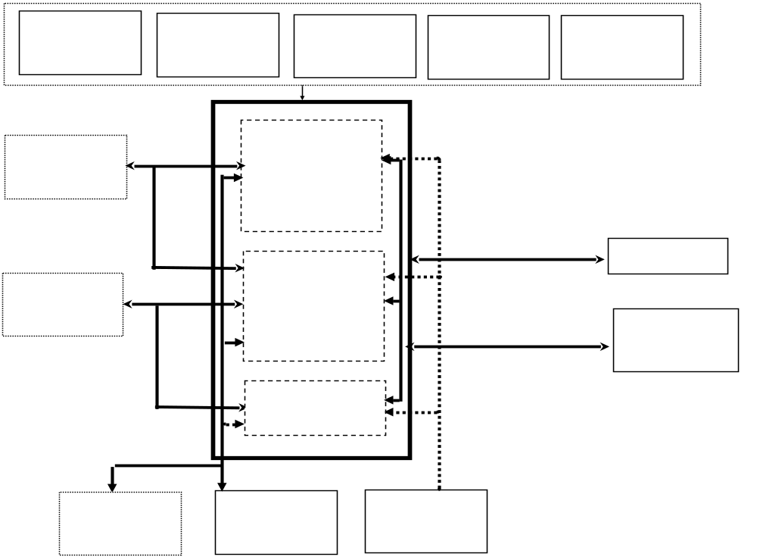
Agents

Abbreviation | Name
PSIC | Punjab Small Industries Corporation
SMEDA | Small and Medium Enterprise Development Authority
EPB | Export Promotion Bureau
VTI | Vocational Training Institute
ATC | Apprentices Training Centre
PLGMEA | Pakistan Leather Garments Manufactures & Exporters Association
PGMEA | Pakistan Gloves Manufactures & Exporters Association

3 VALUE CHAIN
(Leather Jacket Fashion) -(This is an Average Rates for an Average Fashion Jacket)
Storage of Raw Materials
Cutting
Stitching
Finishing
Storage for Shipping
Shipping
Pattern Making
Raw Materials

Leather (/PC): 50 Sf
Zipper (L): 1
Zipper (S): 2
Linings
Thread: 1/2 cone
Sundries:
Fusing/Bonding Material

Costs

60 x 40 2400
1 x 80 80
2 x 10 20
100
0.50 x 50= 25
20
20

Total: Rs 2665

Costs

Rs 25

Costs

Rs 125

Costs

Rs 25

Costs
By Air: Rs 150
By Sea: Rs 50

Finishing Process
Totals

Raw Material= Rs 2665
Pattern making &
Cutting = Rs 25.00
Stitching = Rs 125.00
Finishing = Rs 25.00
Overhead = Rs 35.00
Shipping = Rs 150.00
Cost = Rs 3025.00
Margin = 15 %
Selling price = Rs 3479.00

Rs 16
Purchase of Skin/Hide

Rs 06
Wet Blue Process
Rs 38
(Leather Gloves Fashion)
(This is an Average Rates for an Average Fashion Gloves)
Storage of Raw Materials
Cutting
Stitching
Finishing
Storage for Shipping
Shipping
Pattern Making
Finishing Process
Rs 15
Purchase of Skin/Hide

Rs 06
Wet Blue Process
Rs 34
Raw Materials

Leather (/PC): 6 Sf
Zipper (S): 2
Linings
Thread :1/8 cone
Sundries:
Fusing/Bonding Material

Costs

55 x 5 330
2 x 10 20
30
0.50 x 50= 06
05
05

Total: Rs 396

Costs

Rs 05

Costs

Rs 40

Costs

Rs 05

Totals

Raw Material= Rs 396
Pattern making &
Cutting = Rs 05.00
Stitching = Rs 40.00
Finishing = Rs 05.00
Overhead = Rs 15.00
Shipping = Rs 20.00
Cost = Rs 481.00
Margin = 15 %
Selling price = Rs 553.00

Costs
By Air: Rs 20
By Sea: Rs 10

4. SWOT ANALYSIS OF CLUSTER:

A survey was also conducted to analyse the Strength, weakness, opportunities and Threats (SWOT) of the cluster. This exercise was carried out an extensive secondary and primary research. The analysis of cluster is as follows:

4.1 STRENGTHS:
- Availability of skilled labour.
- Training Institutes for Leather Garments & Gloves LPDI & ATC.
- Govt. Departments like EPB, SMEDA and PSIC who are facilitating the Cluster.
- Trade Bodies like PLGMEA, PGMEA, PSGA, SCCI
- Reliable linkages in international markets
- Sialkot Dry Port Trust and International Air Port (under Construction)
- Strong historical Back Ground of Industrialists which is helping to understand the requirements of clients
- Islamic Slaughtering system which are available within and outside of the Cluster.
- About more than 250 ISO Certified companies

4.2 WEAKNESSES:
- Low worker productivity.
- High turnover ratio of labour (designers, stitchers & managerial staff.
- High cost of production due to high utility bills, Government Taxes, etc
- Ruthless price competition amongst local producers.
- Lack of knowledge about latest Technologies & Lack of Research & Development
- Export on Credit basis to foreign buyers.
- Lack of copy write designs (Pakistani Articles/designs)
- Traditional markets and products. Russian, Latin America, etc are still unexplored, while there is lot of scope in Leather Goods (small products) & Leather Footwear but Cluster’s Export are depending on Leather Garments and Gloves
- Export of low Value added products by SMEs, which one example is Split Leather which are being exported to China, while the product made by Split Leather having more value.
- Non availability of Job placement centre/HR service Centre.
- Non availability of Training in Leather Goods Sector and traditional trainings in Garments & Gloves Sector.
- Unawareness of Social compliance and Environmental issues
- Unawareness about WTO implications.
- Non availability of Chemical Testing Lab. (LPDI or CPC is being worked on establishment of Lab with the collaboration of Norway but under assessment stages. Currently testing facilities of different type of leather in the lab of LPDI which not only consist of complete chemical tests but also not accepted at internationally by the customers.)
- Lack of adoption of new production techniques.

4.3. OPPORTUNITIES:
- Availability of new markets i.e. Russia, Africa, Latin America etc.
- Scope of utilization of Leather Goods in domestic market.
- European countries are closing their Leather businesses due to Environmental Impact and the Leather industry is shifting to thirds world.
- WTO (reduction in tariff barriers)

4.4 THREATS:
- WTO (Environment and Social Compliance issues)
- Imposition of social and environmental regulations by the importing countries.
- Cheep/low price products of China and India, who are capturing international markets
- Latest Developments which are not implementing in Sialkot
- Alternate materials like Curdura and Rexene
- Unawareness of the Industry about the need of upcoming era. Like New styles, raw materials, production techniques etc.

5. MAJOR PROBLEMS AND ISSUES OF THE CLUSTER:

After evaluation of secondary data, Questionnaire, Discussions and Meetings with stakeholders the major issues which identified are as under:

5.1. Technology Constraints:
- Need for Improvement in Latest Leather Finishing Equipments and Machines
- Unawareness and Inaccessibility to various Specialized/Latest Lab facilities

5.2. Marketing Constraints:
- Exploited Export Markets due to absence of concentrated and collective Promotional Campaigns
- Ruthless competition amongst the Exporters which Leads to Price cutting

5.3. Human Resource Constraints:
- Absence of Product Development, Professional Training for Leather Goods
- Lack of Compliance Training

5.4. Regulatory Constraints:
- Working Capital being Held-Up due to delayed payment of Rebate against Export and Sales Tax claims
- Export of non value added Leather Products
- Higher Import duties on raw materials and Chemicals

5.5. Financial Constraints:
- Export on Credit basis (long credit or payment stoppage from the foreign buyer)
- Lack of Finance (Micro or Small entrepreneurs)
- Trading of raw material on Credit without any guarantee

6. PORTER’S FRAMEWORK FOR LEATHER GOODS CLUSTER, SIALKOT

 | Porter’s determinants | Score | Remarks and Status
 | Factor conditions:
1 | Raw material availability | 3 | Raw Material available throughout the year
2 | Quality of raw material | 2 | Quality of raw material is good.
3 | Human resource and skill availability | 3 | Human resource present & skills Labour easily available in Cluster but skaterd
4 | Knowledge of the activity | 3 | Manufactures to manufacturers
5 | Capital availability | 2 | There is no lack of working capital for the manufacturers but small units not availed because they do not have for mortgage.
6 | Availability of infrastructure | 4 | All infrastructure facilities available etc Road connectivity, Dry Port, Air Port, Industrial Estates, Govt. institutions, communication resources are available, consistent power supply & space
 | Demand conditions:
1 | Size of domestic market | 4 | Local market size is very limited
2 | Number of buyers | 3 | No. of buyers is increasing due to winter products and consumable items (gloves etc).
3 | Growth rate of demand | 3 | Growth rate is increasing but slow due to availability of cheaper Chinese products.
4 | Sophistication of buyers | 3 | Customers have quality orientation.
5 | Presence of foreign buyers | 4 | No presence of foreign countries but big potential in European countries.
 | Size and structure of firms:
1 | Number of firms | 4 | Large no. of SMEs involved as manufacturing and makers
2 | Size / efficiency of the firm | 2 | Small units, efficiency limited by management, technology & capital
3 | Existence of rivalry (among firms) | 4 | Intense rivalry among the firms, unorganized & internal price war. Cont…
4 | Formation of new firms | 2 | New trade is feasible realized.
5 | Congruence b/w sub-sector & firm goals | 2 | Quality & design development lead to better margins but manufacturers more bothered about immediate gains.
 | Related and supporting industries:
1 | Design / product development | 1 | No such formalities for design development due to high cost.
2 | Marketing network | 2 | Sub-contracting system with market-led production, traders exploitative.
3 | Market research | 2 | No market research for product diversification or better margins.
4 | Advertising | 2 | Only big players and Medium advertise trough foreign Exhibition only but there is absence of Brand advertise
5 | Training | 3 | Three training institutions LPDI, ATC and VTI available but not fulfilment the modern courses demands of the cluster. Also there is no training on Leather Goods
6 | Research & development | 2 | There is no R & D Institution for product development, better productivity, etc.
7 | Component & machinery suppliers | 2 | New machinery is very expansive import item and machinery & parts supplier/dealer are sufficient in the cluster.
8 | Existence of promotional institutions | 3 | PSIC, SMEDA, EPB, TEVTA, NPO, PNAC, PITAC, PCSIR, Banks, etc. need to be linked
9 | Existence of producer’s associations | 2 | Coops defunct, associations and union uninterested in development activities
 | Code: (1- highly unfavorable, 2- unfavorable, 3- neutral, 4- favorable, 5- highly favorable)

7. CLUSTER VISION

After evaluation of secondary data, Questionnaire, Discussions and Meetings with stakeholders the major issues are identified. Keeping in view issues, the following implementation plans are suggested.

Vision
An increase in the exports of cluster by 20% during the period 2005–2008 is envisaged, i.e. from the present share of export 13,014 Million’s (217 $ Million) of the Pakistan exports of the leather Goods

To increase export sales to 260 million US $ during next 3 years by improving the product quality, entering new alternative distribution channels, increasing existing market share, searching new geographic markets and enhancing productivity through trained human resources.

Targets & Activities

Year 1(July, 2005 to June, 2007)

- Formation of 2 networks of SMEs with the objects of joint Marketing and purchase of raw material.
- Training programmes on Export Marketing and productivity improvement.
- Identification and linkage developing of private BDS providers.
- HR needs assessment of PLGMEA & PGMEA.
- Establishment of Job Placement centre
- Trust & Capacity building workshop & seminars will be arranged.
- Working on establishment of Collection Centre for Testing Point with the help of PCSIR Lahore.
- Launching combine web portal of Leather Cluster
- Developing a concept paper for establishing a Cluster Development Centre for small exporters of LEATHER Sector.
- Developing a concept paper for Establishment of Leather Goods Training Centre
- Creating the awareness & importance of Social Compliance and Environmental / Wastage issues among the firms and prepare the plans to meet these challenges.
- Joint activities by networks
    - Participation in international trade fair.
    - Hiring of marketing BDS for market diversification plans development including Exports & local outlets.
    - Technology up gradation.

8. STRATEGY

8.1. Creating Trust Building among the Entrepreneurs.

First strategy shall focus on creating trust building among the entrepreneurs to stop the price cutting fibrous competition. Trust building activities shall include social gatherings, workshops, lectures, visits to firms, etc

8.2. Market Diversification

Second strategy shall focus market diversification because SMEs principle firms depend on traditional market. Arranging contacts with large buyers/ manufactures, providing new design or information on design sources and providing market information, e.g. export requirements, subcontracting exchange. For the Purpose combine Web Portal would be launched and the activities of the Trade Associations would be enhanced.

8.3. Strategy at micro level and macro level
A 2D strategy has been designed to achieve above targets. Third dimension strategy shall focus on the micro & macro level.

8.3.1 Strategy at micro level
Micro level will focus the networks only. Initially focus will be on formation of networks / linkages develop at least two during the first year. Capacity building exercise of networks will be carried out specifically highlighting the issues of Marketing, Economies of scale & skills etc. As far as marketing focus is concerned, capacity building shall be done emphasizing the “choice of channel” and “logistics”. New distribution channels shall be evaluated and explored.

In operations it will be the “process focused” strategy, concentrating the areas such as “aggregate planning techniques”, “purchase management procedures”, and “bench marking out put levels”.
Self sustainability of networks would be the ultimate objective of above mentioned initiatives.

8.3.2 Strategy at macro level
This level will focus the development of cluster as a whole. It will start with capacity building of two associations namely PGMEA & PLGMEA. These associations shall be used as launching pad for all future cluster development initiatives.

Focus areas would be infrastructure development, including Industrial Development Centre for Leather Goods & Leather testing laboratory, and identification of private BDS providers.
Strong coordination will be build between the two associations such that the efforts have strong trust and greater sustainability.

i)Consortium of entrepreneurs regarding Raw Material Purchasing and Marketing:
In this regard the work has been started and regular visits to the entrepreneurs are in progress. In Sialkot Leather Goods Cluster the informal credit is the major hurdle in joint preaching of raw material. The search of positive minded/same-thinking stakeholders is very important for consortiums/joint ventures. The convincing of joint ventures will take time, because it is new ideology and to force the Cluster for adoption of new techniques/ideology the continue work is required.

ii) Capacity building of entrepreneurs in the areas such as finance, quality production, waste management, market development and product development etc:
Capacity building is very important part of Cluster Development Programme. Keeping in view Leather Goods Cluster and sustainable survival of the Cluster, it is necessary that products should meet all international standards and to search new markets along with exiting markets. For the purpose the awareness about Quality, Market & Product Development and the draw back of informal credit are very essential. With continue visit of the Industry the awareness could be created. This activity is also time taking activity.

iii) Strengthening of Associations:
Trade bodies are playing very vital role in the development of industry, and with the strengthening of Associations the industry will automatically gain incentives. To introduce some activities under Associations for the Industry like Trainings, Job Placement centre, introduction of new markets, arrangements of exhibitions etc, a CDA will very helpful. This activity will not only develop the industry but also strengthen the Associations

iv ) Capacity building of the relevant Institutes:
At present the existing Institutes are unaware about need of Cluster and their courses are old. There is need to upgrade them and convey them the need of Cluster. Refresher courses for the trainers, installation of new machinery and introduction of new technologies/trainings are very important. Under Cluster Development Programme, the capacity building of relevant institutes will enhance the workforce and quality of products.

9. CLUSTER MAP (Future)
Leather Goods. Sialkot

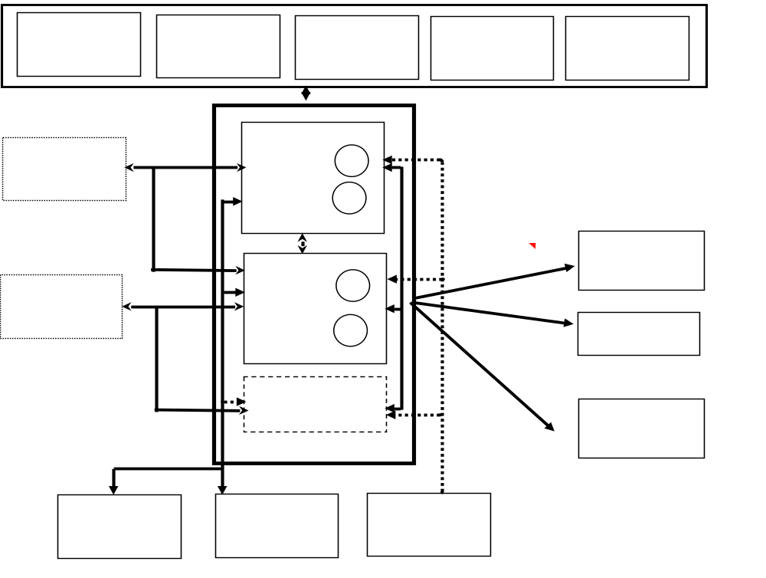
Agents

Abbreviation | Name
PSIC | Punjab Small Industries Corporation
SMEDA | Small and Medium Enterprise Development Authority
EPB | Export Promotion Bureau
VTI | Vocational Training Institute
PLGMEA | Pakistan Leather Garments Manufactures & Exporters Association
PGMEA | Pakistan Gloves Manufactures & Exporters Association

10. TENTATIVE ACTION PLAN

Time Frame |  |  | Expenses
Sr# | Activity | Finish date | PSIC | EPB | SMEDA | UNIDO | Other. | Networks  /Assn. | Implemen  ter
1 | Awareness workshop trust building | Dec-05 | 5,000 |  |  | 10,000 |  | 5,000 | UNIDO,  PSIC
2 | Establishment of Sample Collection centre | Jan -06 |  |  |  |  | PCSIR |  | PCSIR
3 | Creation of a network for exposure visit with the objects of Markting | Mar-06 |  |  |  |  |  | 10,000 | PSIC
4 | Study of a new market | Apr-06 | 5,000 |  |  |  |  | 5,000 | PSIC,  SMEDA
5 | Job Placement Centre | May-06 | 0 | 0 | 0 | 0 |  | 10,000 | PLGMEA
6 | Creation of a network for Marketing | May-06 |  |  |  |  |  | 20,000 | PSIC
7 | Creation of a network for Technological Up gradation | july-06 |  |  |  |  |  | 10,000 | PSIC
8 | Combine Web Portal | Aug-06 | 20,000 |  |  | 20,000 |  | 30,000 | PSIC,  UNIDO, Trade Bodies
9 | Creation of a network for Branding | Dec-06 |  |  |  |  |  | 20,000 | SMEDA
10 | Capacity building plan of Associations | Feb-07 | 10,000 |  |  | 10,000 |  | 10,000 | PSIC,  UNIDO,  EPB
11 | Technological Up-gradation | Jun-07 |  |  | 50% |  |  | 50% | SMEDA
 |  |  | 40,000 | - | - | 40,000 | = | 115,,000

Stake Holders of Leather Products Annex A
S.# | Stake Holder | Detail
1 | Leather Suppliers/Seller | 1. Tannery  2. Shops  3. Brokers
2 | Work Force | 1. Stitchers & Cutters  2. Pattern Master  3. Press man & Fusing man  4. Buttoning & Lacing man  5. Packers  6. Checkers  7. Helpers  8. Other sporting staff, like foreman, Clerks,  Accountants, Machine Operators etc
3 | Raw Material Dealers | 1. Linings  2. Zips, Buttons, Thread, Tags  Buckles, Fusing  3. Pads/Protections  4. Joining materials  5. Packing materials  6. Others small items like  eyelets, elastics, etc
4 | Facility Centres | 1. Knitting  2. Embossing  3. Cutting  4. Water proofing
5 | Govt. Departments | 1. EPB  2. SBR & Sales Tax  3. Dry Port  4. Building Department  5. Labor Department & 6. Social Security,  6. Health Department & EPA  7. WAPDA  8. Sui Gas  9. Telephone
6 | Makers
7 | Import Export Agents /  Freight Forwarders
8 | Chamber of Commerce/  Trade Associations
9 | Testing Labourites
10 | Machinery Seller and repairer
11 | Training Institutes
12 | Service Providers | Pattern Making, Internet, Transport & Courier etc
Annex B

Questionnaire to Evaluate Current Situation of Cluster

PUNJAB SMALL INDUSTRIES CORPORATION

CLUSTER DEVELOPMENT PROGRAMME FOR SMEs IN PUNJAB

Small Industries Estate, U.K Road, Sialkot
Phone: 052-3255475

Name of Organization
Address
 |  |  |  |  |  |  |  |  |  |  |  |  |  |  |  |  |  |  |  |  |  |  |  |  |  |  |  |  |  |  |  |  |  |  |  |  |  |  |  | Year of Establishment
Type of Firm |  | Sole |  |  |  | Partnership |  |  |  |  |  |  |  |  |  |  |  |  | Pvt. Ltd |  |  |  |  |  |  |  |  |  |  | Other
Members |  | Chamber |  |  |  |  |  |  |  |  |  |  | PLGMEA |  |  |  |  |  |  |  |  |  |  | PGMEA |  |  |  |  |  |  |  |  |  |  |  |  |  |  | SGMEA |  |  |  |  |  |  |  |  |  |  |  |  |  |  |  |  |  | Other
Ph # |  |  |  |  |  |  |  |  |  |  |  |  |  |  |  |  |  |  |  |  |  |  |  |  |  |  |  |  |  |  |  |  |  |  |  |  |  |  |  |  |  |  |  |  |  |  |  |  | Fax #
E-mail |  |  |  |  |  |  |  |  |  |  |  |  |  |  |  |  |  |  |  |  |  |  |  |  |  |  |  |  |  |  |  |  |  | URL
Name of Owner
Contact Person |  |  |  |  |  |  |  |  |  |  |  |  |  |  |  |  |  |  |  |  |  |  |  |  |  |  |  |  |  |  |  |  | Designation
Type of Product |  | Leather |  |  |  |  |  |  |  |  |  |  |  |  |  |  |  |  |  |  |  |  |  |  |  |  |  |  |  |  |  |  | Garments
 |  | Gloves |  |  |  |  |  |  |  |  |  |  |  |  |  |  |  |  |  |  |  |  |  |  |  |  |  |  |  |  |  |  |  |  |  | Shoes
 |  | Goods |  |  |  |  |  |  |  |  |  |  |  |  |  |  |  |  |  |  |  |  |  |  |  |  |  |  |  |  |  |  |  |  |  | Other
Consumption %age |  | Local Market |  |  |  |  |  |  |  |  |  |  |  |  |  |  |  |  |  |  |  |  |  |  |  |  |  | Export |  |  |  |  |  |  |  |  |  |  |  |  |  |  |  |  |  |  |  |  |  |  |  | Showroom
Major Buyers Countries/ Industry (Mention type)
Marketing Procedure
No of Employees |  | 01 – 09 |  |  |  |  |  |  |  |  |  |  |  |  |  | 10 – 35 |  |  |  |  |  |  |  |  |  |  |  |  |  |  | 36 – 99 |  |  |  |  |  |  |  |  |  |  |  |  |  |  |  |  |  |  |  |  |  |  |  | 100 Above
Out Source Work
Installed Capacity
Current Production |  |  |  |  |  |  |  |  |  |  |  |  |  |  |  |  |  |  |  |  |  |  |  |  |  |  |  |  |  |  |  |  |  |  |  |  |  |  |  |  |  | Working Days
By Product Generated
Disposal of By Product
Annual Revenue
Last Five Year Production/Revenue | 2000 |  |  |  |  |  |  |  |  |  |  |  |  |  |  |  |  |  |  | 2001 |  |  |  |  |  |  |  |  |  |  |  |  |  |  |  |  |  |  |  |  |  |  |  |  |  |  | 2002
Last Five Year Production/Revenue | 2003 |  |  |  |  |  |  |  |  |  |  |  |  |  |  |  |  |  |  | 2004
Peak Season |  |  |  |  |  |  |  |  |  |  |  |  |  |  |  |  |  |  |  | Off Season
Type of Raw Materials
Availability |  |  | Import |  |  |  |  |  |  | Local Market |  |  |  |  |  |  |  |  |  |  |  |  |  |  |  | Out of City |  |  |  |  |  |  |  |  |  |  |  |  |  |  |  |  | Other

WTO & ISO Certification:

Knowledge about WTO | Yes |  | No |  | WTO Preparation |  | Yes |  | No
ISO Certification | Yes |  | No |  | If Yes, Which One

Reasons of Increase_______ or Decrease______ in Production/Revenue

S.# | Detail
01
02
03
04
05

Major Problems Faced by the Unit

S.# | Detail | Remarks
01
02
03
04
05

Assistance/Facilities Required
S.# | Detail | Remarks
01
02
03
04
05

Any Other Information

S.# | Detail | Remarks
01
02
03
04
05

Personal Observations

__________________________________________________________________________________________________________________________________________________________________________________________________________________________________________
Date:___________ S.#_______________

Annex C
List of Trade Bodies, Institutes & Public / Private Organizations at Sialkot

Trade Associations linked up with Leather Cluster at Sialkot:

Sialkot Chamber of Commerce and Industry (SCCI)
Members about 7,000
Shahrah-e-Aiwan-e-Sanat-o-Tijart, Sialkot
Phone: 052-4291881-83, Fax: 052-4268835
E-mail: scci@skt.comsats.net.pk

Pakistan Leather Garments Manufacturers and Exporters Association (PLGMEA))
Members 116 (Northern Zone)
B.A.S.F Building, Defence Road, Sialkot
Phone: 052-3254401-03, Fax: 052-3254400
E-mail: plgmea@gjr.paknet.com.pk

Pakistan Gloves Manufacturers and Exporters Association (PGMEA)
Members about 300
PGMEA Building, Kashmir Road, Sialkot
Phone: 052-4272959 & 4273870,
Fax: 052-4274860
E-mail: pgmea@brain.net.pk

Pakistan Sports Goods Manufacturers & Exporters Association (PSGA)
Members 386
Paris Road, Sialkot
Phone: 052-4267962 & 4265080,
Fax: 052-261774
E-mail: psga@brain.net.pk

Institutes related to Leather Garments and Gloves Training:

Govt. Apprenticeship Training Centre (ATC)
Under Technical Education & Vocational Training Authority (TEVTA)
P.O Gohad Pur, Marala Road, Sialkot
Phone: 052-3556638

Punjab Vocational Training Centre (VTC)
Under Punjab Vocational Training Council (PVTC)
Small Industrial Estate, I, Uggoki Road, Sialkot
Phone: 052-3562708, Fax: 052-3258349

Leather Products Development Institute (LPDI)
Under EPB/PGMEA
Defence Road, Allama Iqbal Town, Sialkot
Phone: 052-3550590 & 3257266, Fax: 052-3561139

Public / Private Departments for Facilitation of the Industry at Sialkot:

Export Promotion Bureau (EPB)
Paris Road, Sialkot
Phone: 052-9250081, 9250083-86
Fax: 052-9250082

Punjab Small Industries Corporation (PSIC)
S.I.E, Uggoki Road, Sialkot
Phone: 052-3255475

Small & Medium Enterprises Development Authority (SMEDA)
C/O SCCI, Shahrah-e-Aiwan-e-Sanat-o-Tijart, Sialkot
Phone: 052-4291881-83
Fax: 052-4268835

Cleaner Production Centre (CPC)
Allama Iqbal Town, Defence Road, Sialkot
Phone: 052-3550590,
Fax: 052-3561139

Annex D

Main Category of Leather & its Products

1- Garments
Motor Bike, Fashion, Protective, Etc

2- Gloves
Working, Fashion, Sports, Military, Etc

3- Shoes
Fashion, Sports, Military, Etc

4- Goods
Sadlery, Bags, Belts, Straps, Decoration Pcs, Cases, Wallets, Jewelry, Musical instruments, Etc

5- Sports Goods,
Cricket Balls, Hand Balls, Foot Balls, Etc

6- Furniture Leather
Home Furniture and Automobile Industry, Etc

7- Industrial Leather
Seals, Bags, Stripes, Belts, etc.

8- Finished Leather
Garments, Gloves, Shoes, Goods, Etc

Annex E
Graf of Sialkot Export 1999 to 2004
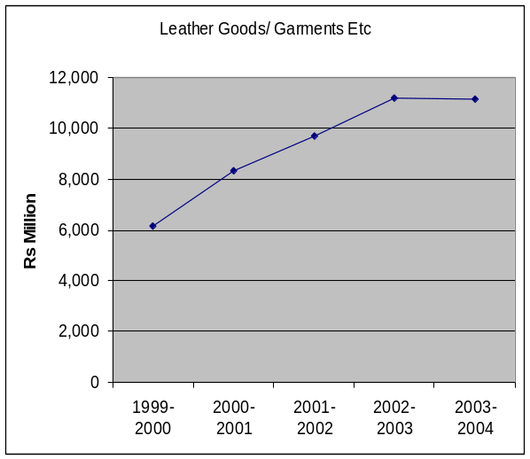 | 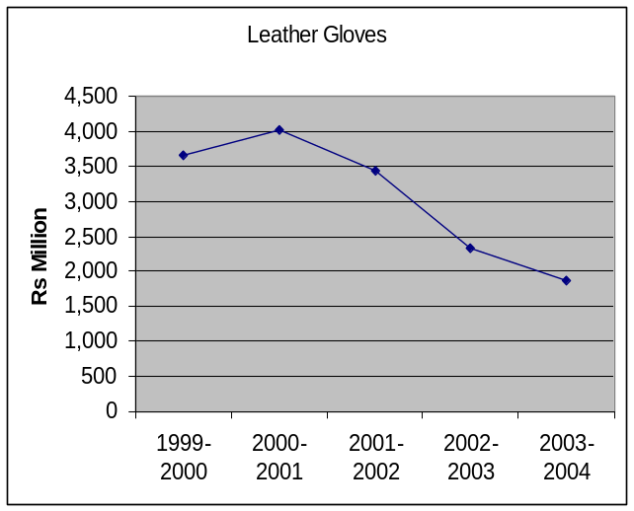
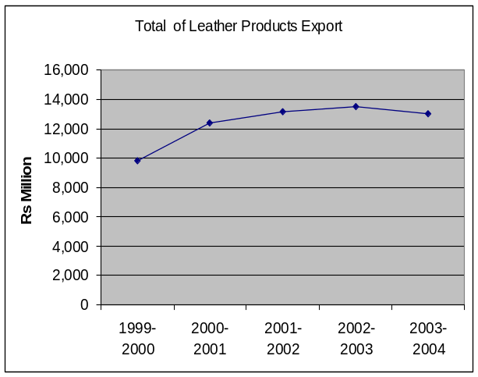 | 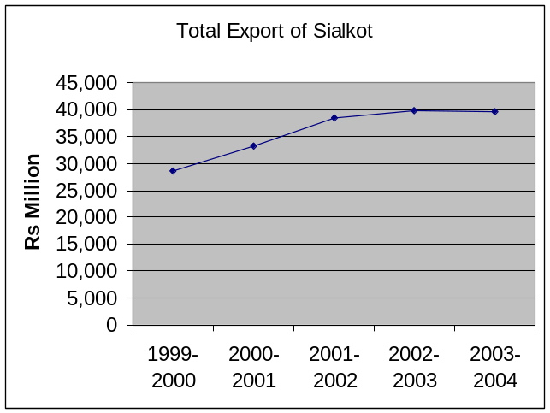
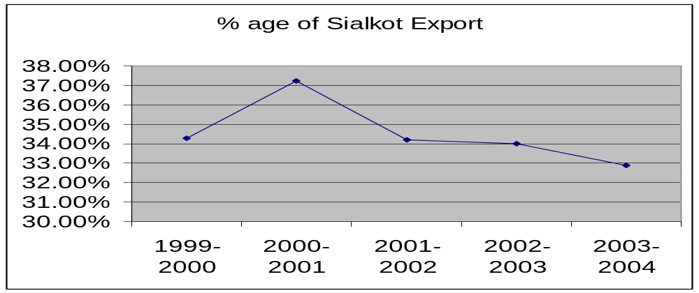
Source: Sialkot Dry Port Trust
Annex F

IULTCS OFFICIAL METHODS OF ANALYSIS OF LEATHER AND ITS PRODUCTS

IULTCS - CHEMICAL TEST METHODS

IU No. | Method Name
IUC 1 | General comments
IUC 2 | Sampling
IUC 3 | Preparation of test material by grinding
IUC 4 | Determination of substances (fats and other solubles) soluble in Dichloromethane.
IUC 5 | Determination of volatile matter
IUC 6 | Determination of water soluble matter, water soluble inorganic matter and water soluble organic matter
IUC 7 | Determination of sulphated total ash and sulphated water insoluble ash
IUC 8 | Determination of chromic oxide
IUC 9 | Determination of water soluble magnesium salts
IUC 10 | Determination of nitrogen and hide substance
IUC 11 | Determination of pH and difference figure
IUC 13 | Determination of zirconium
IUC 15 | Determination of phosphorus
IUC 16 | Determination of aluminium
IUC 17 | Determination of hydroxyproline in materials containing collagen
IUC 18 | Photometric Determination of chromium (VI) using 1, 5 - Diphenylcarbazide
IUC 19 | Determination of formaldehyde content of Leather
IUC 20 | Method for the detection of certain AZO colourants in dyed Leather
IUC 21 | Method for the detection of certain AZO colourants in dyestuff mixtures
IUC 22 | Determination of aluminium oxide content of aluminium tanning agents
IUC 23 | Determination of the pH of aqueous solutions of aluminium tanning agents
IUC 24 | Determination of basicity of aluminium tanning agents.
IUC 25 | Determination of pentachlorophenol content

IULTCS - PHYSICAL TEST METHODS

IU No. | Method Name
IUP 1 | General remarks
IUP 2 | Sampling
IUP 3 | Conditioning
IUP 4 | Measurement of thickness
IUP 5 | Measurement of apparent density
IUP 6 | Measurement of tensile strength and percentage elongation
IUP 7 | Measurement of static absorption of water
IUP 8 | Measurement of tear load - Double edge tear
IUP 9 | Measurement of distension and strength of grain by the Ball Burst Test
IUP 10 | Water resistance of flexible Leather
IUP 11 | Measurement of water resistance of heavy Leather
IUP 12 | Measurement of resistance to grain cracking and the grain crack index
IUP 13 | Measurement of two dimensional extension
IUP 14 | Measurement of waterproofness of gloving Leathers
IUP 15 | Measurement of water vapour permeability
IUP 16 | Measurement of shrinkage temperature up to 100 °C
IUP 17 | Assessment of the resistance of air dry insole Leathers to heat
IUP 18 | Resistance of air dry lining Leathers to heat
IUP 19 | Resistance of air dry upper Leather to heat
IUP 20 | Measurement of flex resistance by flexometer method
IUP 21 | Measurement of set in lasting
IUP 22 | Assessment of scuff damage by use of the viewing box
IUP 23 | Measurement of scuff damage
IUP 24 | Measurement of surface shrinkage by immersion in boiling water
IUP 26 | Measurement of resistance to abrasion of heavy Leather
IUP 28 | Measurement of the resistance to bending of heavy Leather
IUP 29 | Measurement of cold crack temperature of surface coatings
IUP 30 | Measurement of water vapour absorption and desorption (See IUP 42)
IUP 32 | Measurement of area
IUP 35 | Measurement of dry heat resistance of Leather
IUP 36 | Measurement of Leather softness
Draft IUP 37 | Measurement of water repellancy of garment Leather
IUP 38 | Measurement of heat resistance of patent Leather
IUP 39 | Measurement of flex resistance by the vamp flex method
IUP 40 | Measurement of tear load - Single edge tear
IUP 41 | Measurement of surface coating thickness
IUP 42 | Measurement of water vapour absorption
IUP 43 | Measurement of extension set
IUP 44 | Measurement of stitch tear resistance
Draft IUP 45 | Measurement of water penetration pressure
Draft IUP 46 | Measurement of fogging characteristics
Draft IUP 47 | Measurement of resistance to horizontal spread of flame
Draft IUP 48 | Measurement of abrasion resistance of upholstery Leather
Development | Measurement of bagginess (IUP 49)
Development | Measurement of soiling (IUP 50)
Development | Measurement of Surface Friction (IUP 51)
Development | Measurement of Compressibility (IUP 52)

IULTCS - FASTNESS TEST METHODS

IU No. | Method name
IUF 105 | Numbering code for fastness tests
IUF 120 | Principles of colour fastness testing
IUF 131 | Grey scale for assessing change in colour
IUF 132 | Grey scale for assessing staining
IUF 151 | Preparation of Standard Storable Chrome Leather
IUF 201 | Approx. determination of solubility of Leather dyes
IUF 202 | Fastness to acid of dye solutions
IUF 203 | Stability to acid of dye solutions
IUF 205 | Stability to hardness of dye solutions
IUF 401 | Fastness to daylight
IUF 402 | Fastness to light (Xenon arc)
IUF 420 | Fastness to water spotting
IUF 421 | Fastness to water
IUF 423 | Fastness to washing
IUF 424 | Fastness to formaldehyde
IUF 426 | Fastness to perspiration
IUF 434 | Fastness to dry-cleaning of small samples
IUF 435 | Fastness to machine washing
IUF 441 | Fastness in respect to staining raw crepe rubber
IUF 442 | Fastness in respect of staining plasticised PVC
IUF 450 | Fastness to and fro rubbing
IUF 454 | Fastness to buffing of dyed Leather
IUF 458 | Fastness to ironing
IUF 470 | Adhesion of finish
IUF 412 | Change of colour with accelerated ageing

Annex G
List of Secondary Data/Directories
S.# | Detail | Organization/Source
01 | Directory of Leather & its Products Sialkot | LIDO
02 | Leather Directory 1994 | LIDO
03 | Tannery Directory of Sialkot | CPC
04 | Value Chain | www.themanager.org
05 | Foreign Trade of Pakistan 2001-2002 | EPB
06 | Spot Analysis of Leather sector | EPB
07 | Acceptable Quality Levels in Leather | UNIDO
08 | Pakistan Economic Up date (selected pages) | Pakistan Economic Survey
09 | Sialkot Dry port Press Release (Nov 04) | Sialkot Dry Port
10 | Export from Pakistan (Nov 04) | EPB
11 | Export Statistics of Gloves (1978-2004) | PGMEA
12 | Member list of PSGMA | PSGMA
13 | Export from Sialkot Dry Port (2003-2004) | Sialkot Dry Port
14 | Export of Leather Goods from Sialkot(1993-2004) | Sialkot dry port
15 | Export from Sialkot Dry Port (1987-2004) | Sialkot Dry Port
16 | Comparative Export Figures of Last 3 year (May 01-May 03 Leather and Leather Manufacturers) | EPB
17 | 5 years of Pakistan’s Trade (1997-2002) | EPB
20 | Member list of PLGMEA | PLGMEA
21 | Foreign Trade of Pakistan (2000-2001) (selected pages) | EPB
22 | Foreign Trade of Pakistan 1999-2000 | EPB
23 | Member list of PGMEA | PGMEA
24 | Exhibitions Directory World Wide (Leather Related) | Kuwait C.C.I
25 | International Exhibitions with WPB (18 May to 18 Nov) | EPB
26 | Pre-Investment Study on Sialkot 2002 | Directorate of Industries
27 | Directory of Industrial Development Punjab (Soft Copy) | Directorate of Industries
28 | Sialkot Brief | Sialkot Chamber
29 | List of Members of Pakistan Sports Goods Association | PSGA
30 | SRO 0638(I)/2004 (Raw Material imports) | CBR
31 | CDP, Leather Cluster, Karachi | UNIDO web site
32 | Exports/Imports of Pakistan (1999-2003) related to Leather | www.intracen.org
33 | Leather Statistics 1995-1999 | www.indianLeatherportal.com
34 | IULTCS Official Method of Analysis | www.tannerscouncilict.org
35 | Importing/Exporting Countries Leather and its Products (1999-2003) | www.Leatherindia.org
36 | Exports Leather Clothing Access, Clothing, Footwear, Gloves and Belts World wide 1999-2003 | www.intracen.org
37 | Exports Leather Clothing, Gloves, Footwear and Belts Pakistan 1999-2003 | www.intracen.org
38 | Foreign Trade of Pakistan 2003-2004 | EPB
39 | Over Group Tanneries | www.overgroup.it
40 | UNIDO Cluster Development Projects | www.pakistan.gov.pk/.......

Annex H
List of Firms who Filled Questionnaire
S.# | COMPANY | TYPE OF PRODUCTS
1 | SHAMAS JACKET MAKER | GARMENTS
2 | U.K. SPORTS | GOODS
3 | A. B. LEATHER | LEATHER
4 | IBRAHIM JACKET MAKER | GARMENTS
5 | SANI GLOVES | LEATHER
6 | BASIR JACKET MAKER | GARMENTS
7 | M. YOUSAF BELT MAKERS | GOODS
8 | BAKHTAIAR INDUSTRIES | GLOVES
9 | TOP MAN SHOES | SHOES
10 | LEATHER SOFT INDUSTRIES | LEATHER GLOVES
11 | WEST GATE INTERNATIONAL | LEATHER GARMENTS
12 | SUBAN ALLAH LEATHER | GARMENTS
13 | ADEEB ENTERPRISE | LEATHER
14 | H.T. GLOVES MAKERS | GLOVES
15 | ALI TRADING CO. | LEATHER GLOVES GOODS
16 | AL ADNAN | GOODS
17 | DAR TANNERIES | LEATHER GARMENTS
18 | AL KHAIR LEATHER WORK | LEATHER GARMENTS
19 | KARAMAT JACKET MAKER | GARMENTS
20 | CUIR TECH | GARMENTS
21 | PAK NORWAGIEN INTERNATIONAL | GARMENTS
22 | PAKNAS LEATHER | LEATHER
23 | NEW MG RUSTAM & CO | GOODS
24 | MAFT INDUTRIES | LEATHER GLOVES
25 | YASEEN LEATHER | LEATHER GARMENTS
26 | OOFY HORSE | GLOVES/ GOODS
27 | METASCO INTERNATIONAL | LEATHER, GLOVES, GARMENTS
28 | MASHA ALLAH TANNERY | LEATHER
29 | M. SADIQUE GLOVES MAKER | LEATHER GLOVES
30 | UMER LEATHER | GARMENTS GLOVES
31 | RASEB INDUSTRIES | GLOVES
32 | NEW ROSE INDUSTRIES | GLOVES
33 | RUSTAM & CO | LEATHER GOODS
34 | RASA INTERNATIONAL LEATHER | GOODS GLOVES GARMENTS
35 | A. S. LEATHER | LEATHER
36 | CHANNEL INDUSTRIES | GLOVES GARMENTS
37 | PATENT LEATHER INDUSTRIES | GARMENTS
38 | PAK BUNELUX SAFTY WEARS | LEATHER GLOVES
39 | EIFA PLUS | GOODS
40 | FIRCOS SHOES | SHOES
41 | FATEH MUHAMMAD & SONS | GOODS
42 | THE QUALITY PRODUCTS | LEATHER GLOVES
43 | GLANCE LEATHER INDUSTRIES | LEATHER GARMENTS
44 | TOP FLIGHT LEATHER | LEATHER GLOVES
45 | SHEIKH OF SIALKOT | SHOES GARMENTS
46 | SIALKO PAK SPORTS | LEATHER GLOVES
47 | COSMOPOLITAN ENTERPRICES | LEATHER GOOD GARMENTS
48 | PADANA GARMENTS (PVT) LTD | LEATHER GARMENTS GLOVES
49 | RASI INTERNATIONAL | LEATHER GARMENTS
50 | NEW NATIONAL TANNERY | LEATHER GLOVES
51 | F S CANDINO | GLOVES
52 | LITTLE WOOD CORPORATION | LEATHER GARMENTS, GLOVES
Annex I
Abbreviation
ATC Apprenticeship Training Centre
BILLION One Thousand Million (1,000,000,000)
CCI Chamber of Commerce and Industry
CDA Cluster Development Agent
CDP Cluster Development Programme
CFC Common Facility Centre
CPC Cleaner Production Centre
EPB Export Promotion Bureau
LIDO Leather Industry Development Organization
LPDI Leather Products Development Centre
MOC Ministry of Commerce
MOIP Ministry of Industries and Production
MOST Ministry of Science and Technology
NPO National Productivity Organization
PSIC Punjab Small Industries Corporation
PGMEA Pakistan Gloves manufacturers & Exporters Association
PLGMEA Pakistan Leather Garments Manufacturers & Exports Association
PSGA Pakistan Sports Goods Manufacturers & Exporters Association
PVTC Punjab Vocational Training Centre
SCCI Sialkot Chamber of Commerce & Industry
SDPT Sialkot Dry Port Trust
SME Small & Medium Enterprises
SMEDA Small & Medium Enterprises Development Authority
SWOT Strength, Weaknesses Opportunities, Threat
TEVTA Technical Education & Vocational Training Authority
UNIDO United Nation Industrial Development Organization
US $ United States Dollar (1 US $ = 60 Pak Rupees)
WTO World Trade Organization

